Anemometer
# Source: AI Source: Provided by: [Data Path: Persons Table -> ID Column: 1, Name_En Column: Motasem Essam] -> From: [ChatGPT] on [7/17/2026]
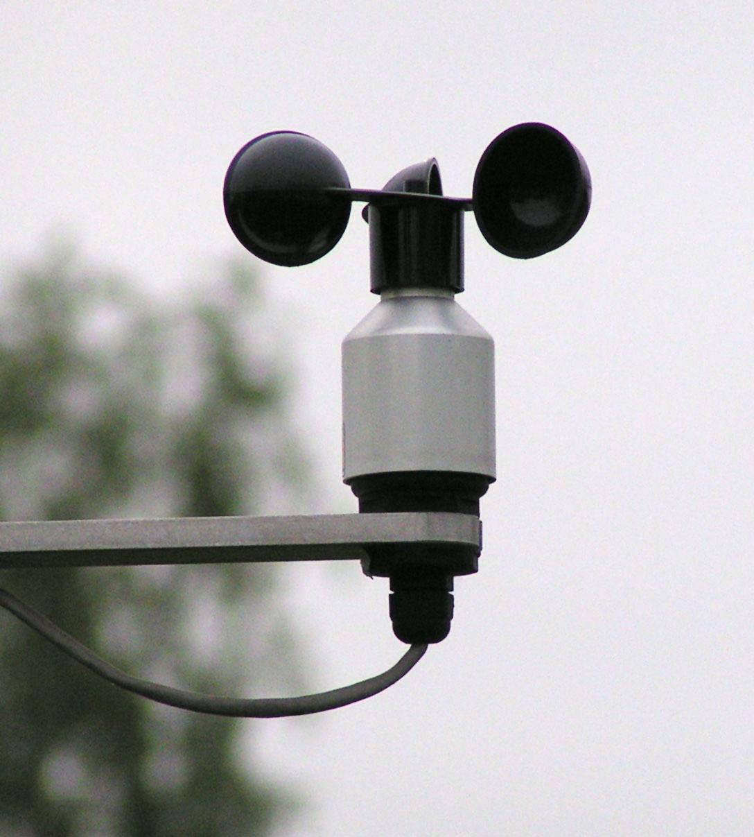
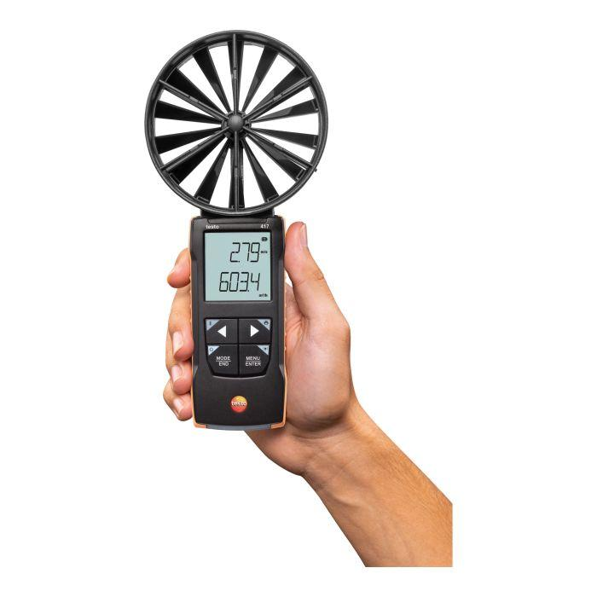
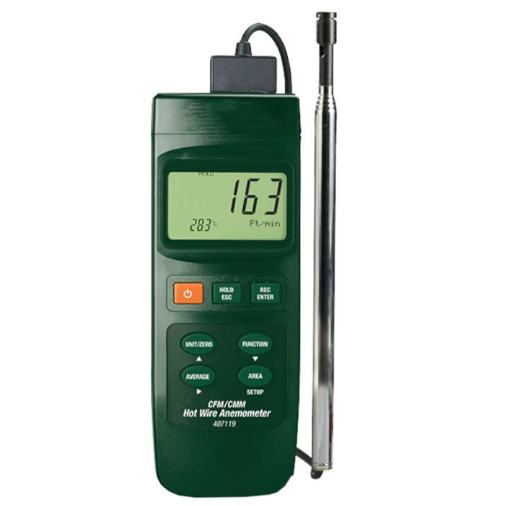
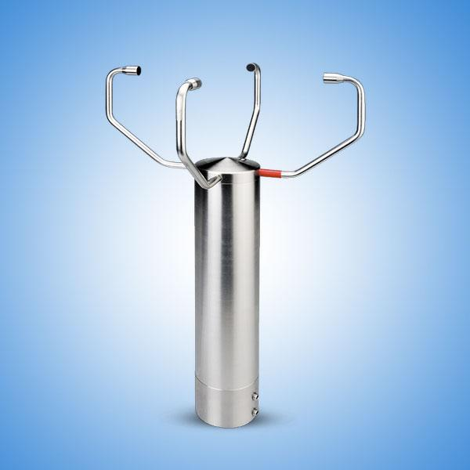
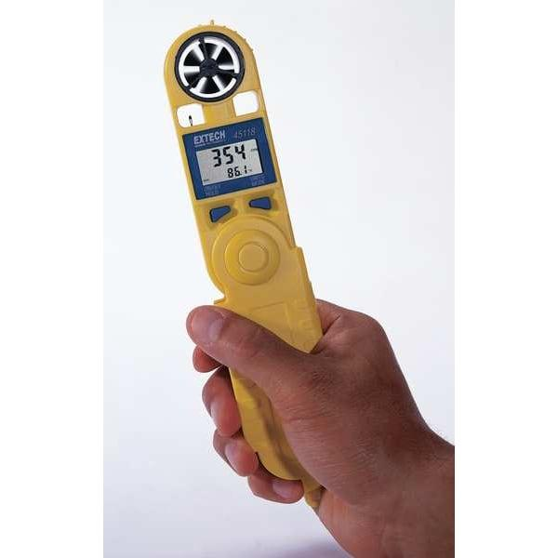
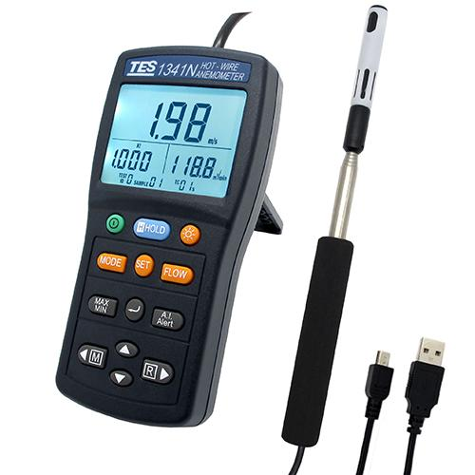
An Anemometer is a speed-measuring instrument used to measure the speed of moving air (wind). It is one of the most important instruments in meteorology, aviation, HVAC systems, environmental monitoring, wind energy, marine navigation, and scientific research.
Different types of anemometers measure wind speed using rotating cups, propellers, heated sensors, ultrasonic waves, or pressure differences.

Definition
# Source: AI Source: Provided by: [Data Path: Persons Table -> ID Column: 1, Name_En Column: Motasem Essam] -> From: [ChatGPT] on [7/17/2026]
An Anemometer is an instrument used to measure the speed of moving air or wind.

Purpose
# Source: AI Source: Provided by: [Data Path: Persons Table -> ID Column: 1, Name_En Column: Motasem Essam] -> From: [ChatGPT] on [7/17/2026]
An anemometer is used to:
- Measure wind speed.
- Monitor weather conditions.
- Evaluate ventilation systems.
- Measure airflow in HVAC ducts.
- Monitor wind turbines.
- Support aviation safety.
- Conduct environmental studies.
- Measure air velocity in laboratories.

Principle of Operation
# Source: AI Source: Provided by: [Data Path: Persons Table -> ID Column: 1, Name_En Column: Motasem Essam] -> From: [ChatGPT] on [7/17/2026]
The operating principle depends on the type of anemometer.
Cup Anemometer
Wind rotates three or four cups. The rotational speed is proportional to wind speed.
Vane (Propeller) Anemometer
Wind rotates a propeller aligned with the airflow.
Hot-Wire Anemometer
A heated wire cools as air flows past it. The cooling rate is used to calculate air velocity.
Ultrasonic Anemometer
Measures the travel time of ultrasonic sound waves between sensors to calculate wind speed.

Main Components
# Source: AI Source: Provided by: [Data Path: Persons Table -> ID Column: 1, Name_En Column: Motasem Essam] -> From: [ChatGPT] on [7/17/2026]
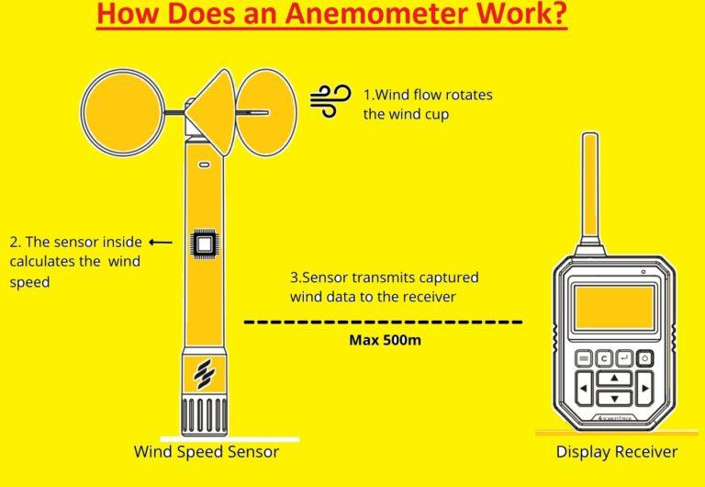
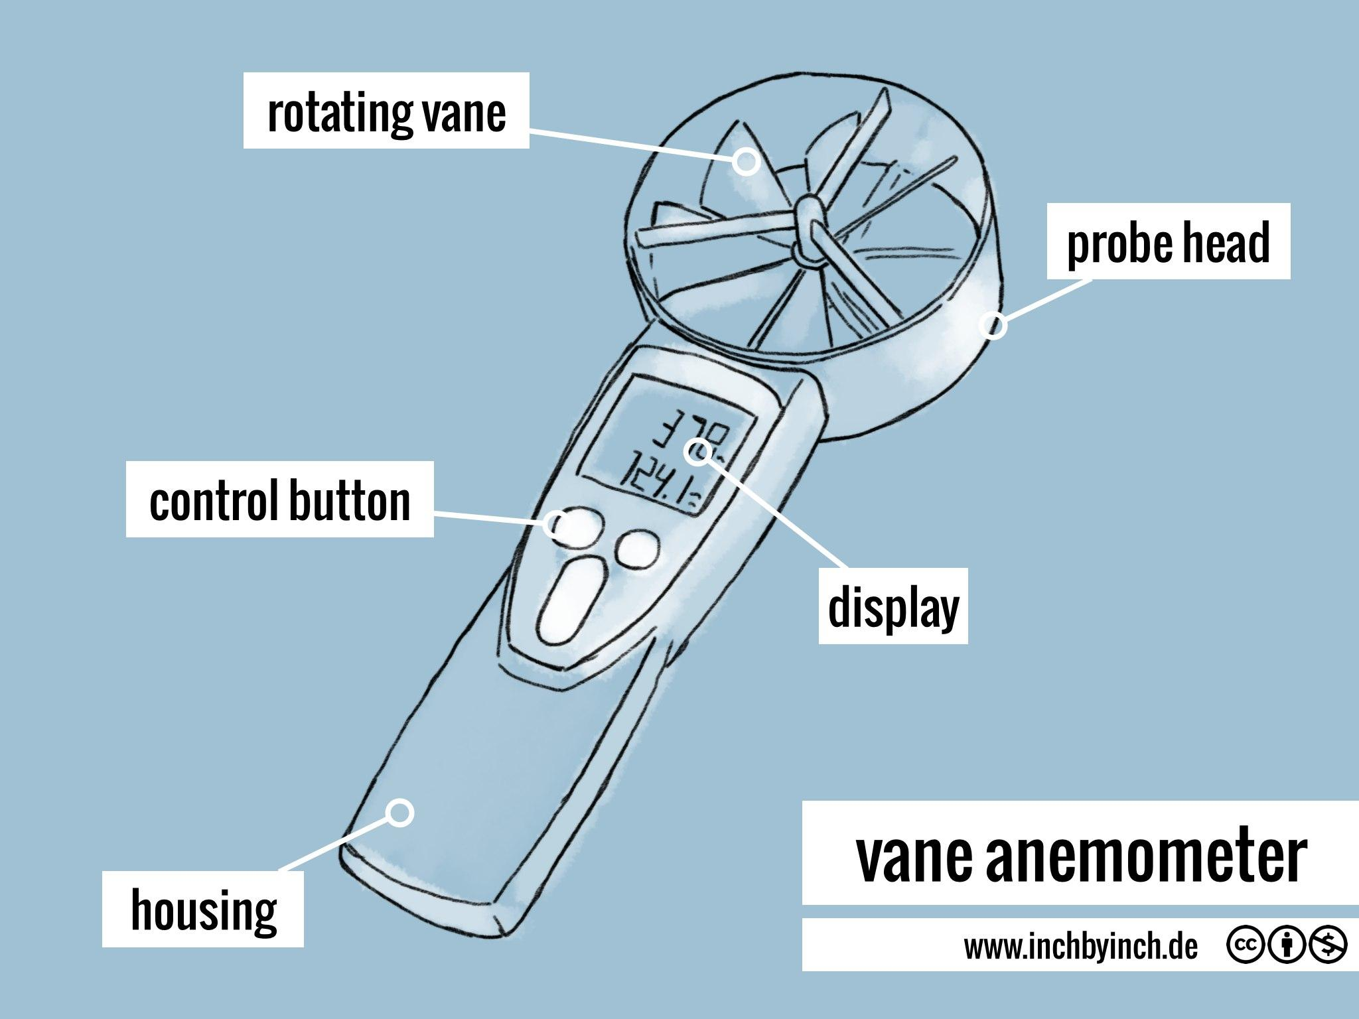
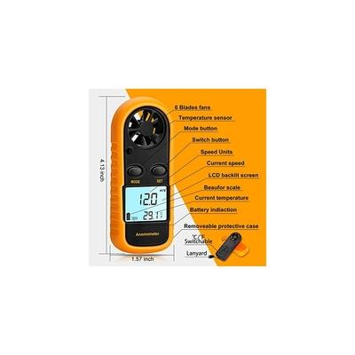
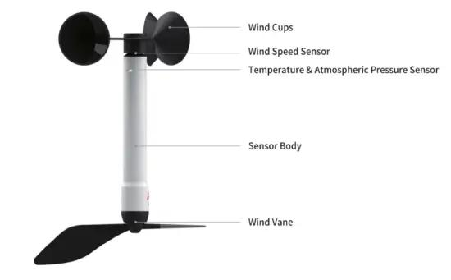
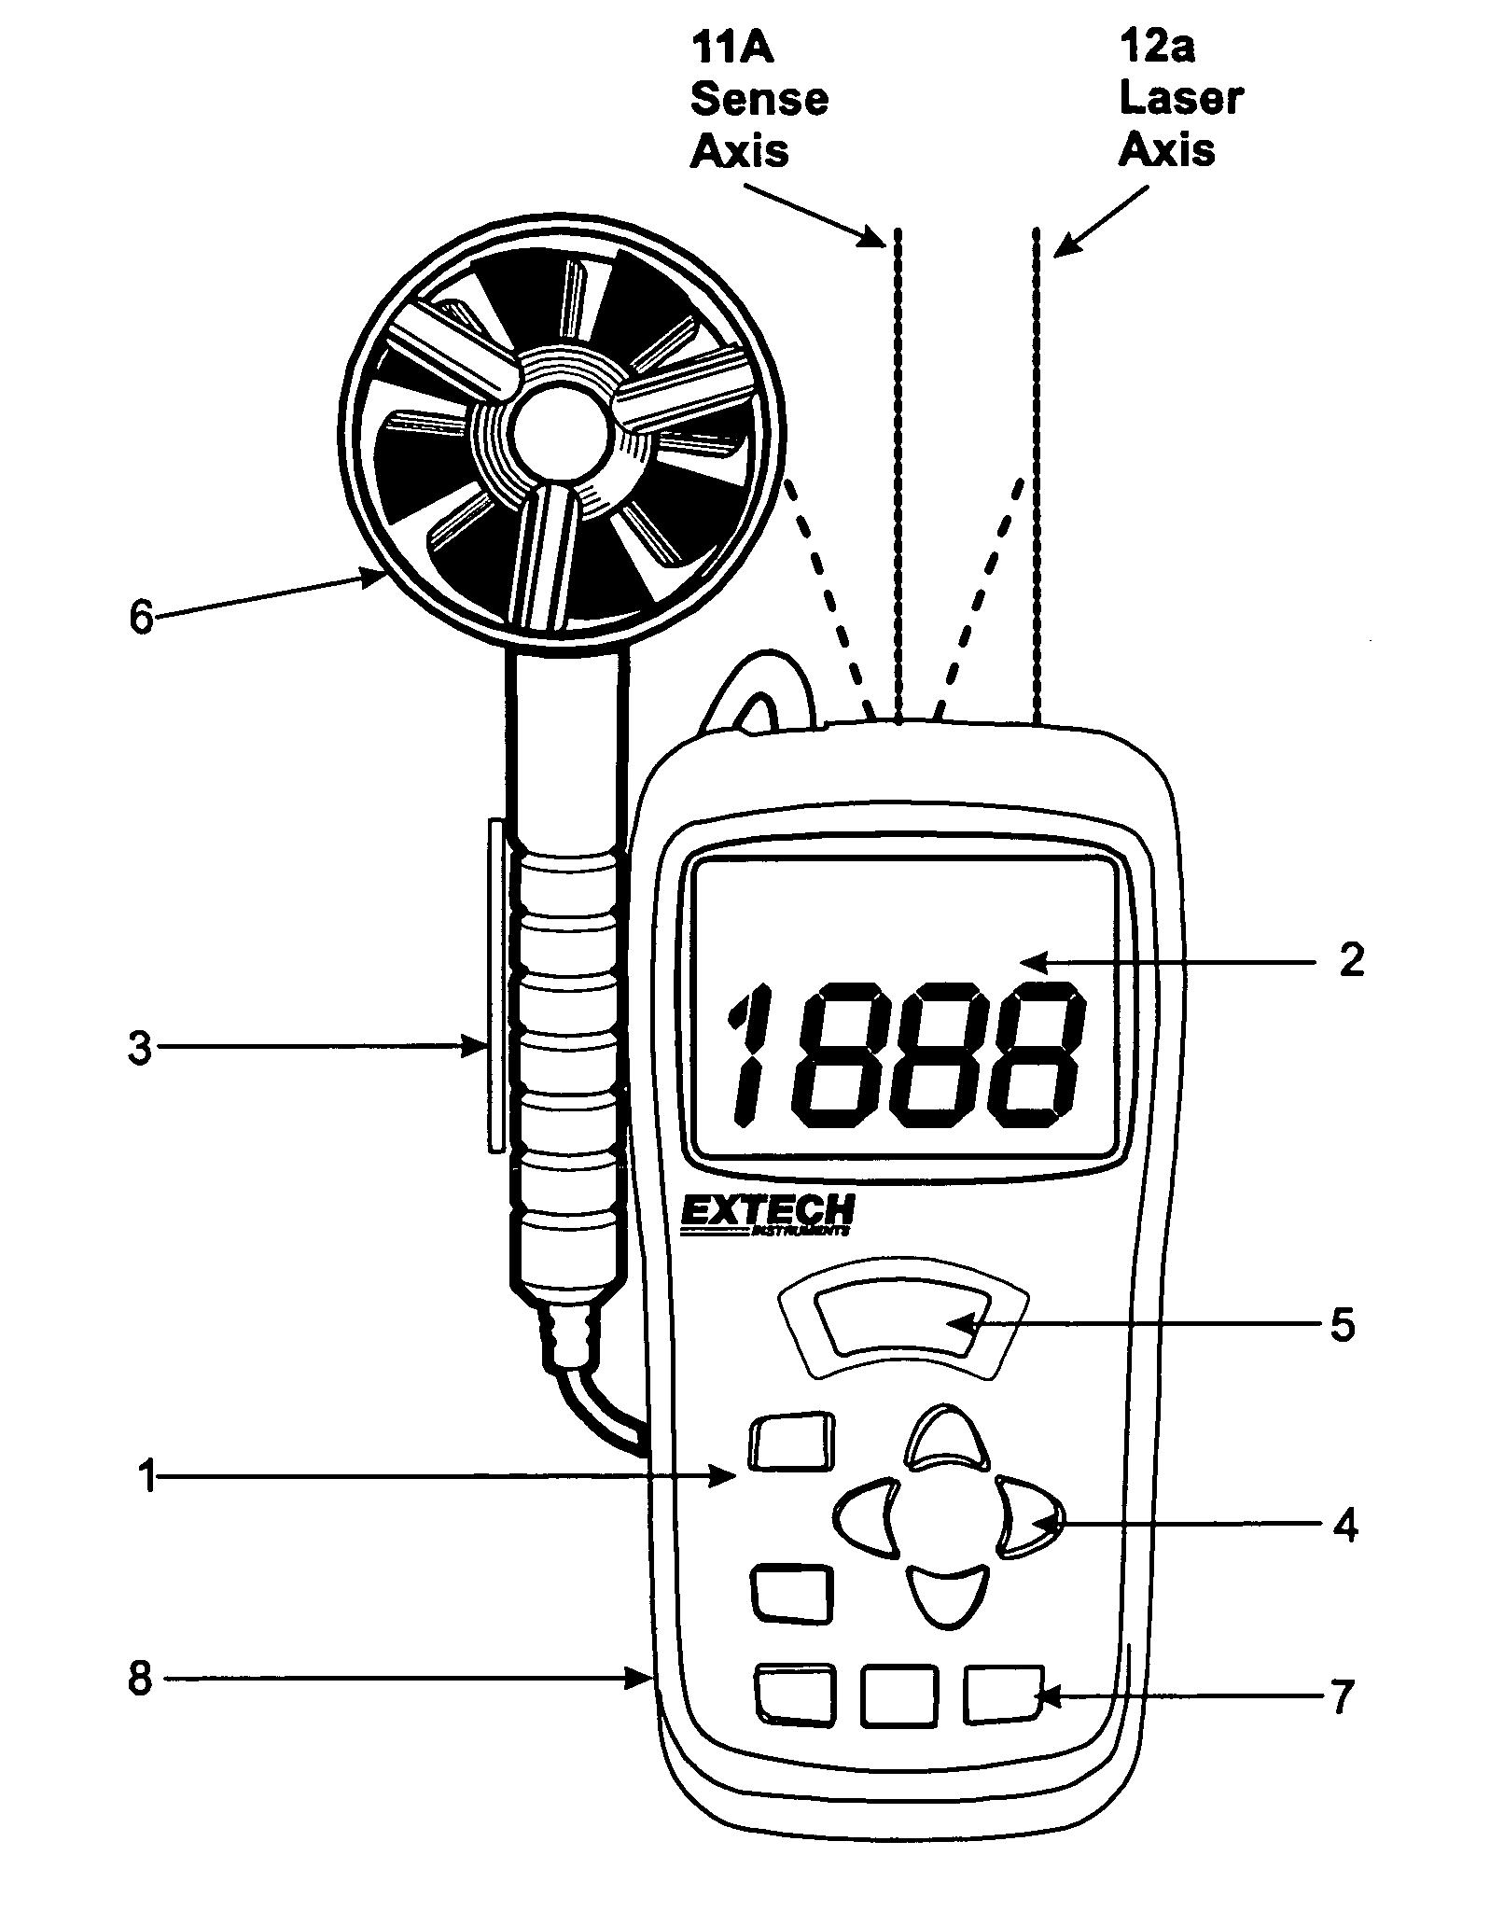
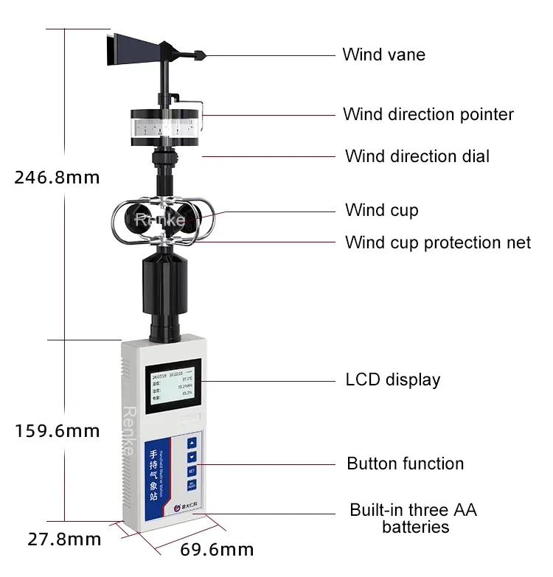
A typical anemometer consists of:
- Wind sensor
- Rotating cups or propeller (depending on type)
- Electronic processor
- Digital display
- Power source
- Mounting system

Types of Anemometers

1. Cup Anemometer
# Source: AI Source: Provided by: [Data Path: Persons Table -> ID Column: 1, Name_En Column: Motasem Essam] -> From: [ChatGPT] on [7/17/2026

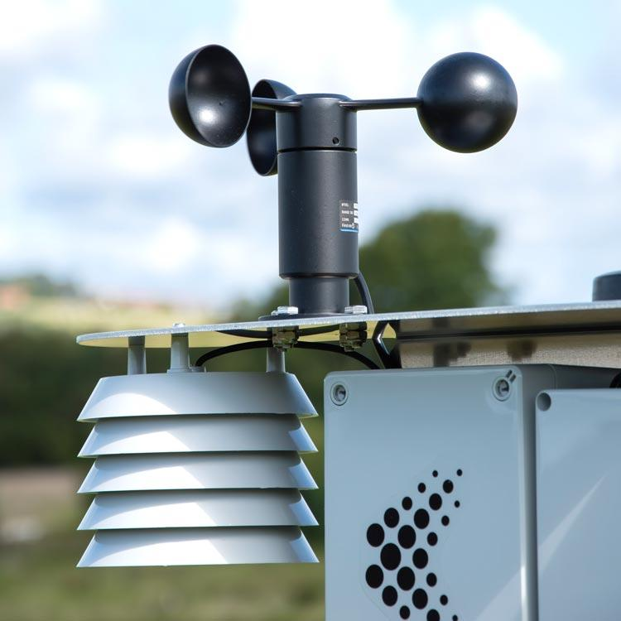
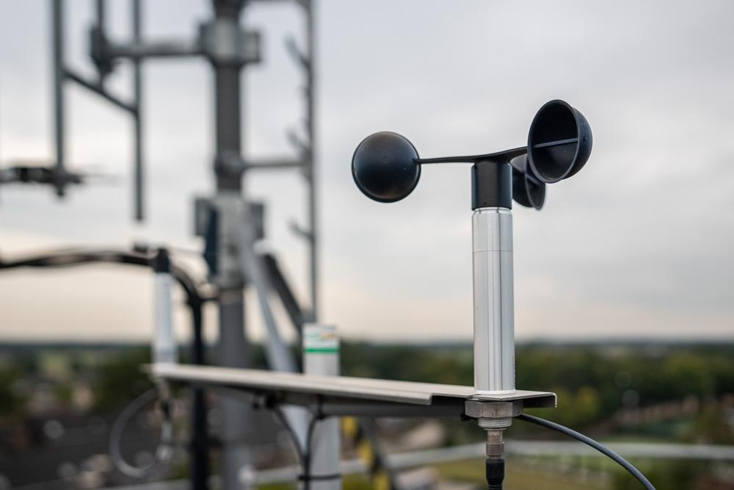
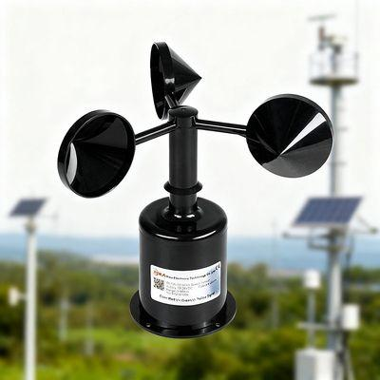
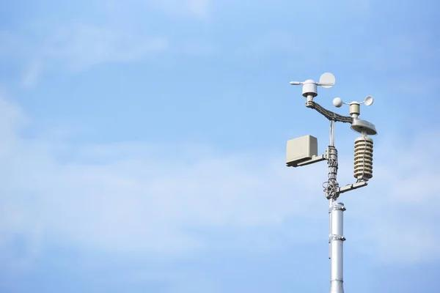
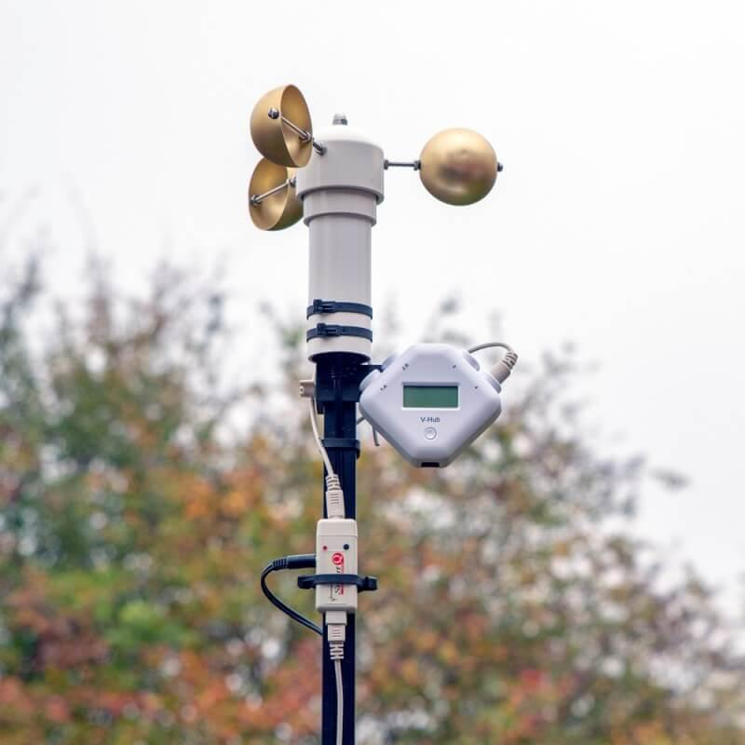
Description
Measures wind speed using three or four rotating cups mounted on horizontal arms. Wind causes the cups to rotate, and the rotational speed is converted into wind speed.
Features
- Simple and robust design
- Continuous outdoor operation
- Standard instrument for weather stations
Applications
- Meteorology
- Weather stations
- Wind farms
- Environmental monitoring

2. Vane (Propeller) Anemometer
# Source: AI Source: Provided by: [Data Path: Persons Table -> ID Column: 1, Name_En Column: Motasem Essam] -> From: [ChatGPT] on [7/17/2026
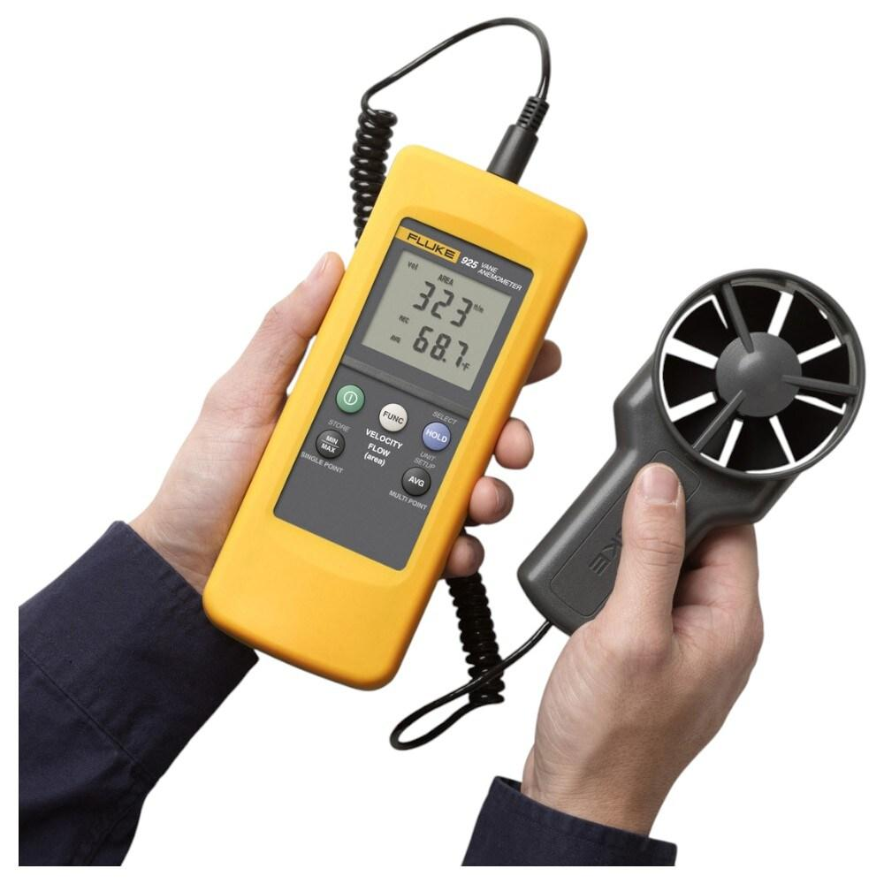
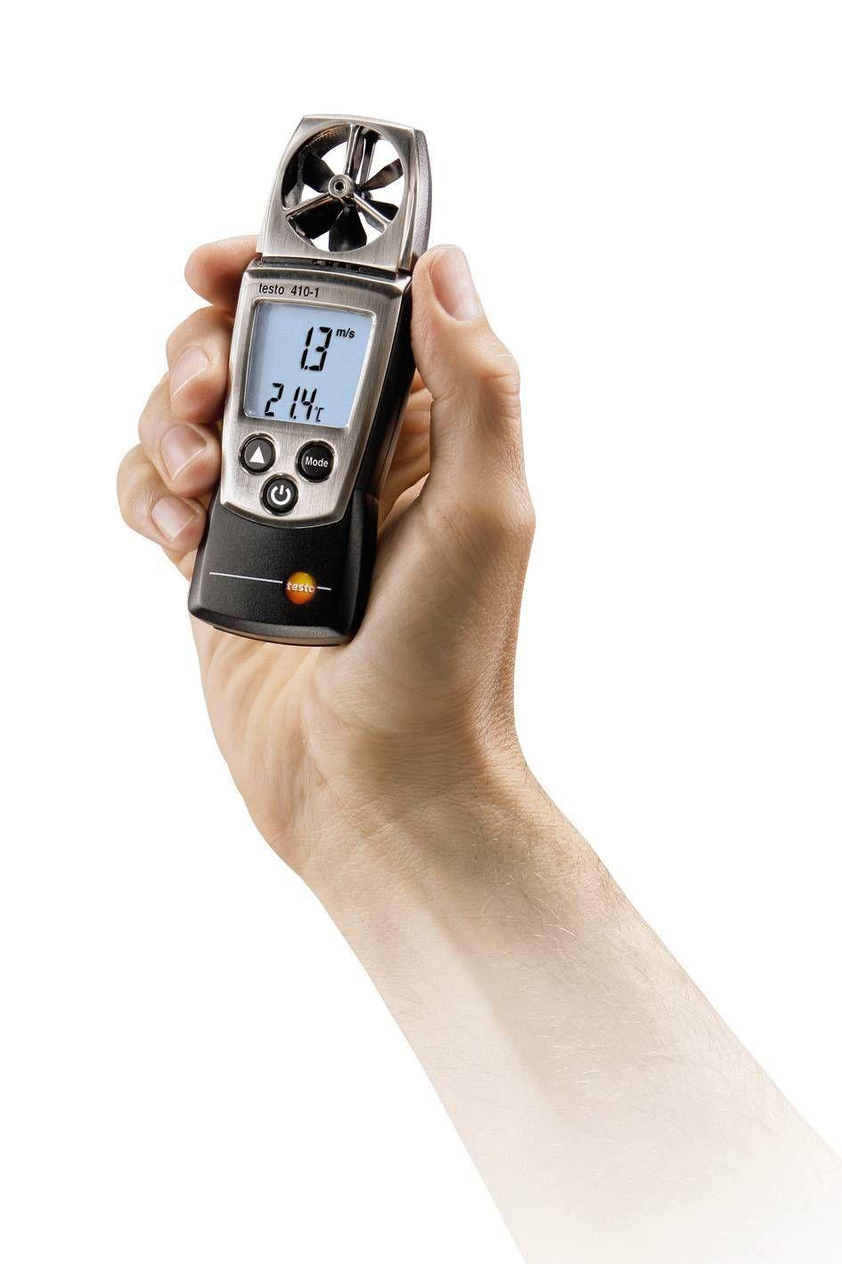
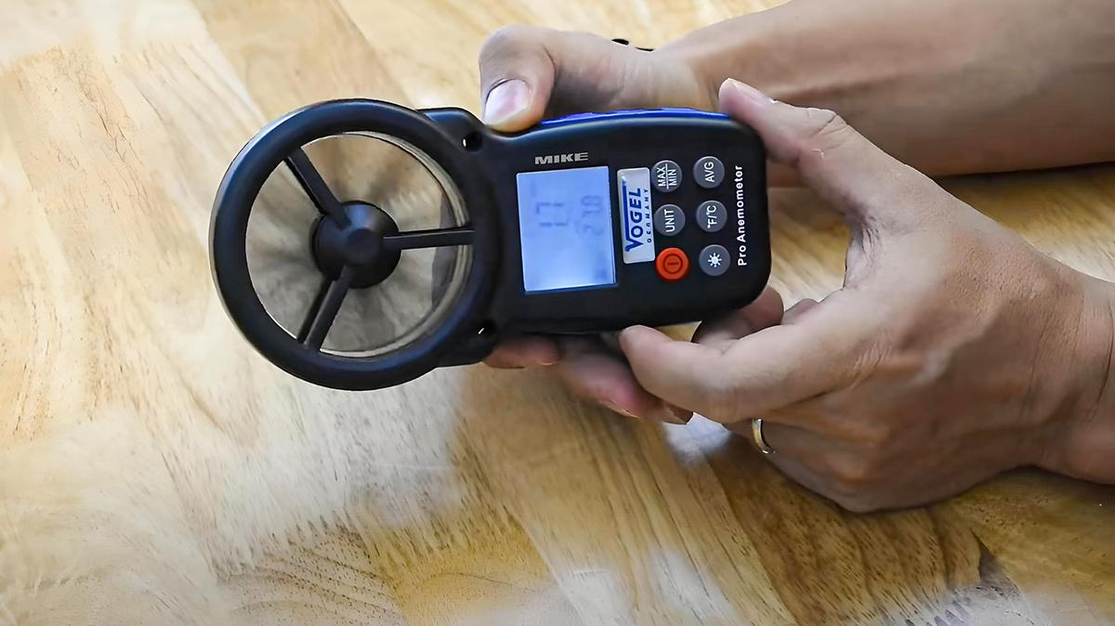
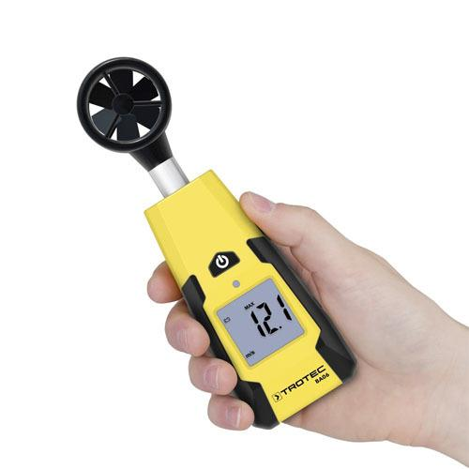
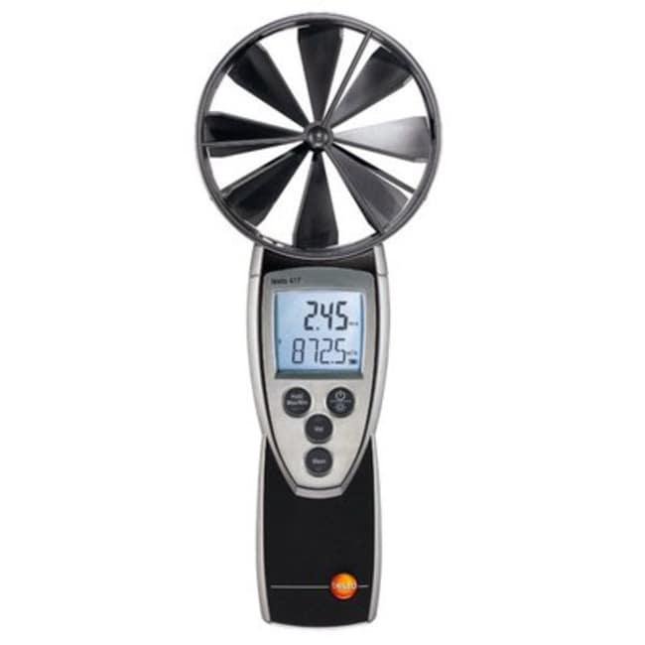
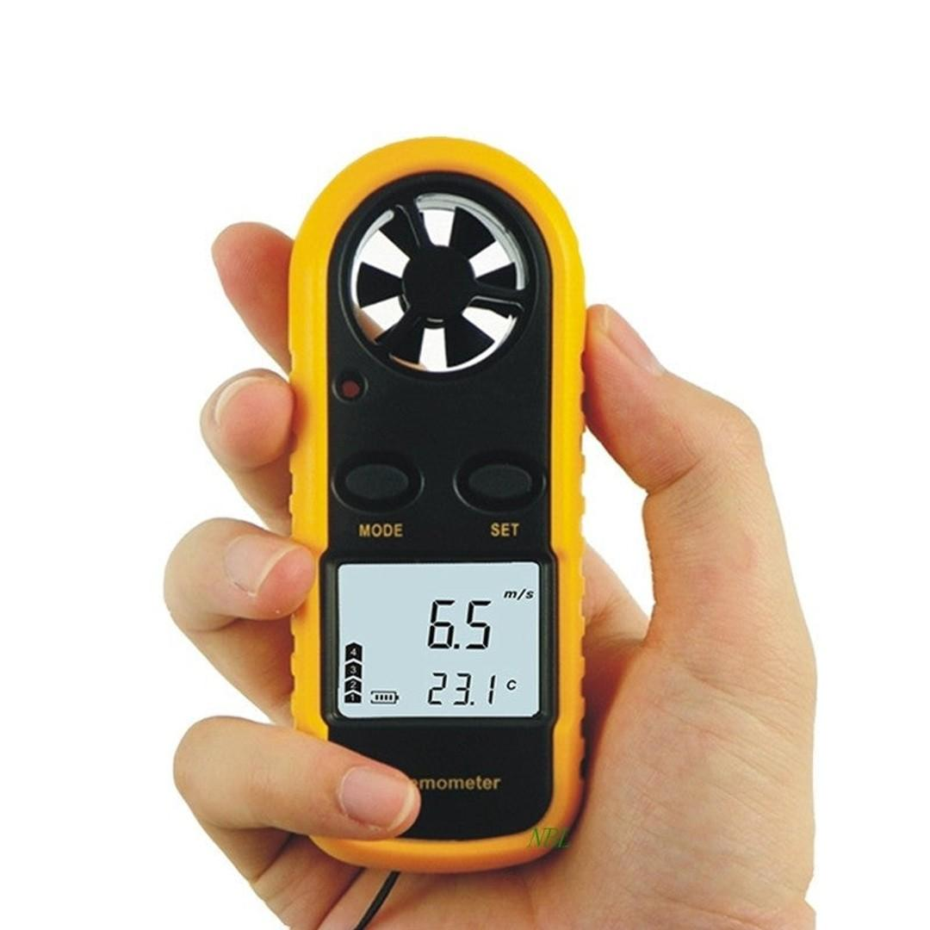
Description
Uses a propeller (vane) that rotates when exposed to airflow. Many models also measure wind direction.
Features
- Handheld or fixed installation
- Good for measuring airflow in ducts
- Measures both air velocity and direction (some models)
Applications
- HVAC systems
- Ventilation testing
- Air-conditioning maintenance
- Laboratories

3. Hot-Wire Anemometer
# Source: AI Source: Provided by: [Data Path: Persons Table -> ID Column: 1, Name_En Column: Motasem Essam] -> From: [ChatGPT] on [7/17/2026
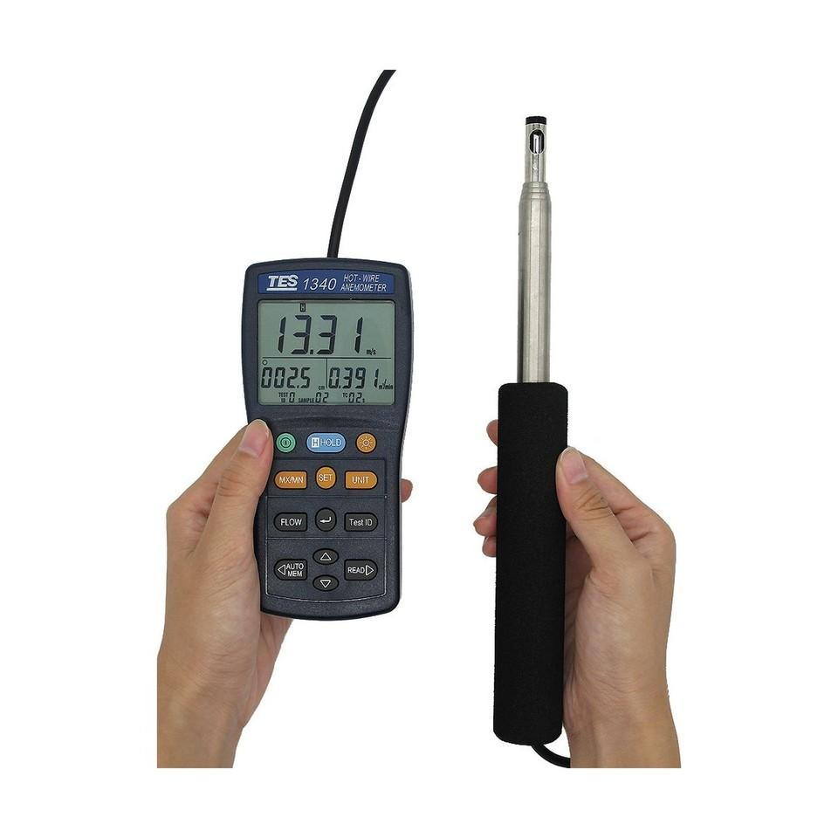
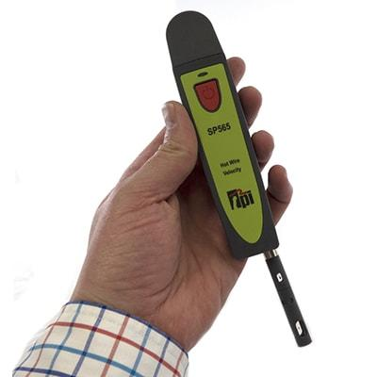
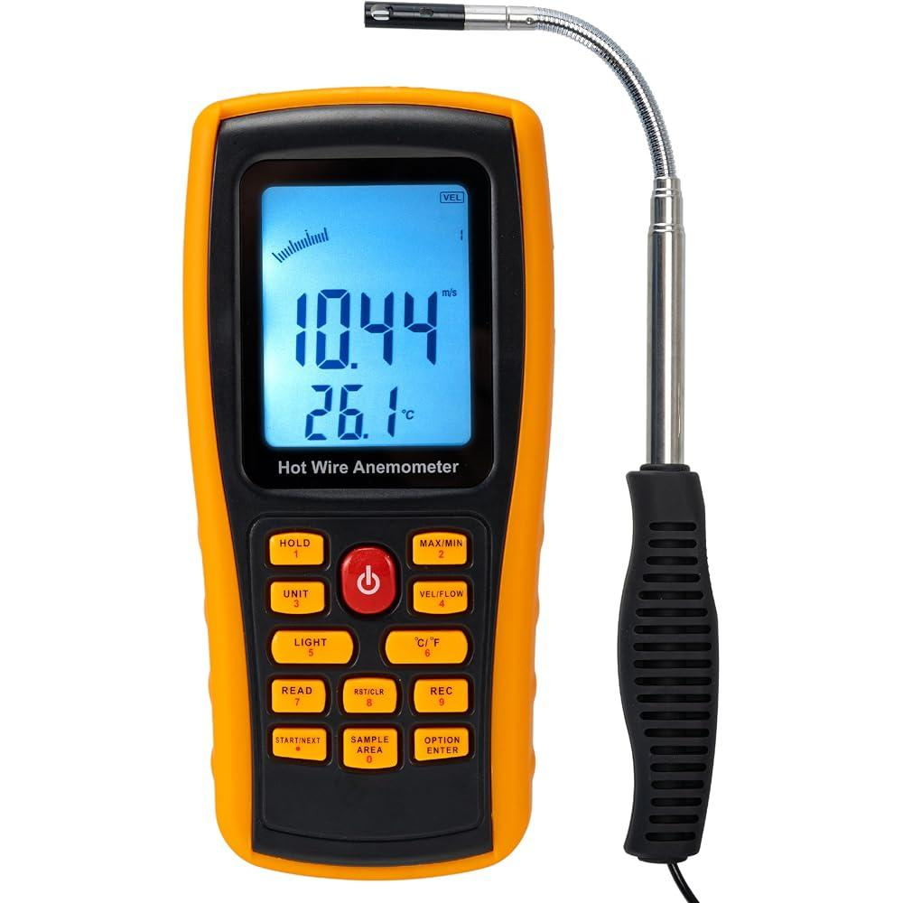
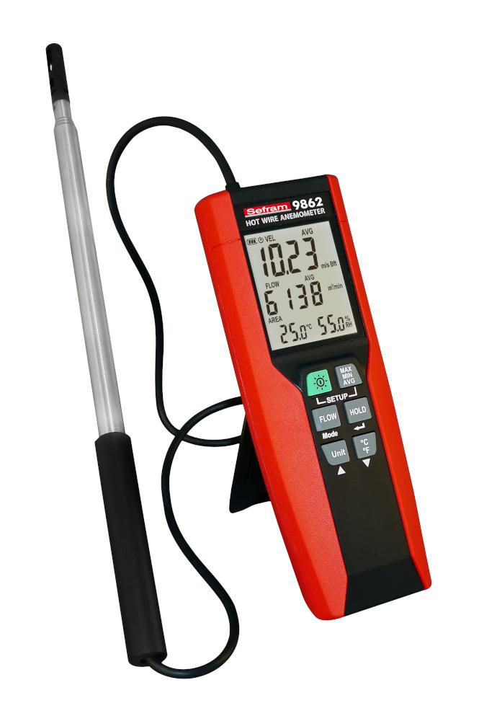
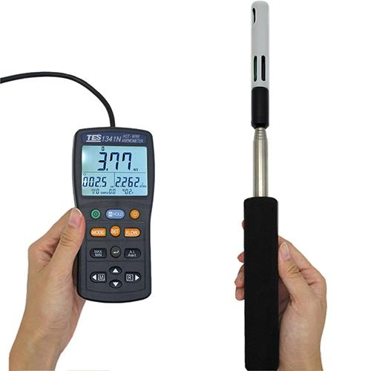
Description
Measures airflow by monitoring the cooling effect of moving air on a heated wire.
Features
- Extremely sensitive
- Excellent for low-speed airflow
- High precision
Applications
- Research laboratories
- Wind tunnel testing
- HVAC airflow measurement
- Scientific experiments

4. Ultrasonic Anemometer
# Source: AI Source: Provided by: [Data Path: Persons Table -> ID Column: 1, Name_En Column: Motasem Essam] -> From: [ChatGPT] on [7/17/2026
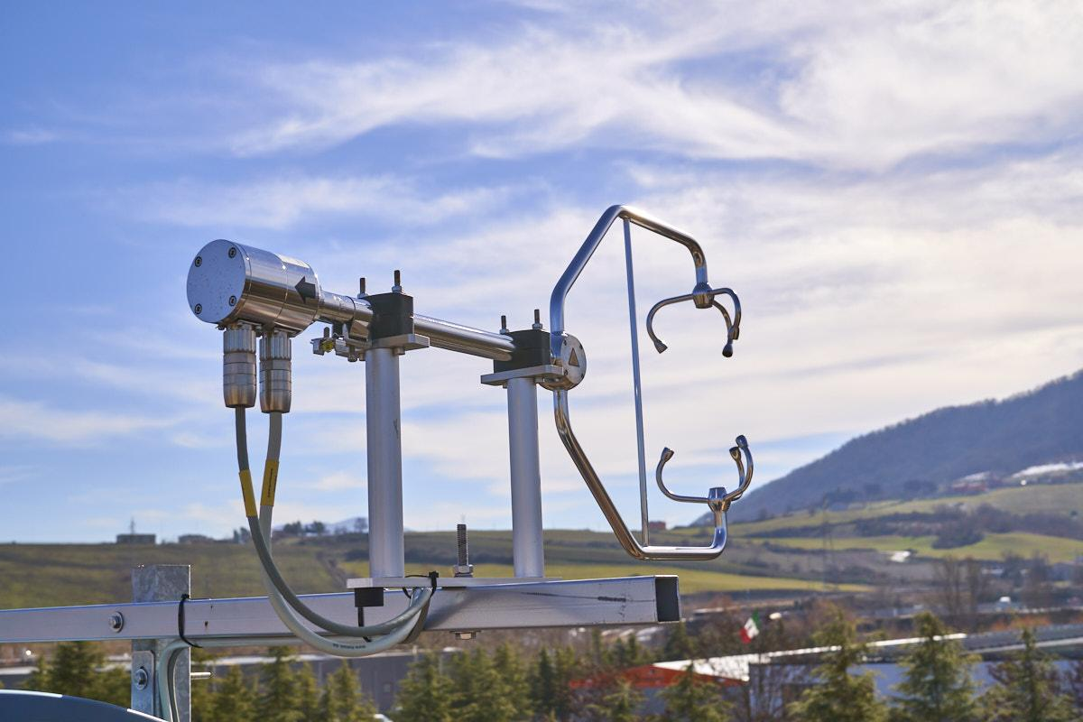
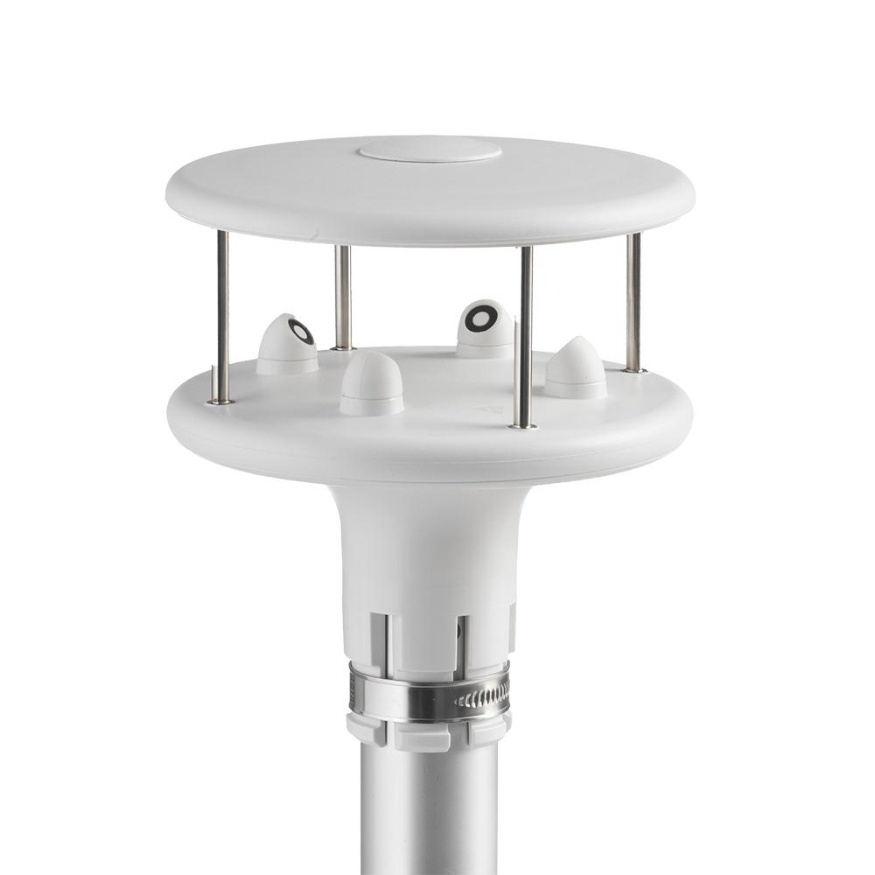
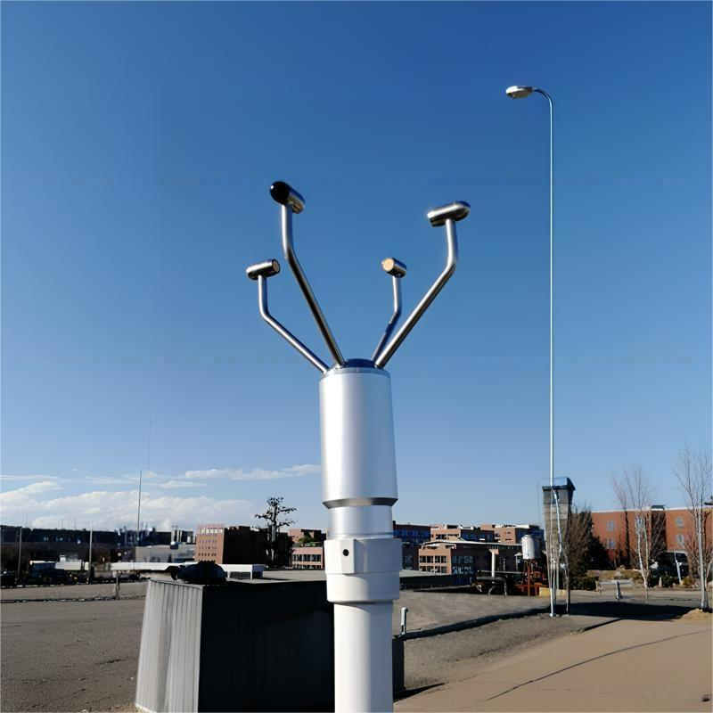
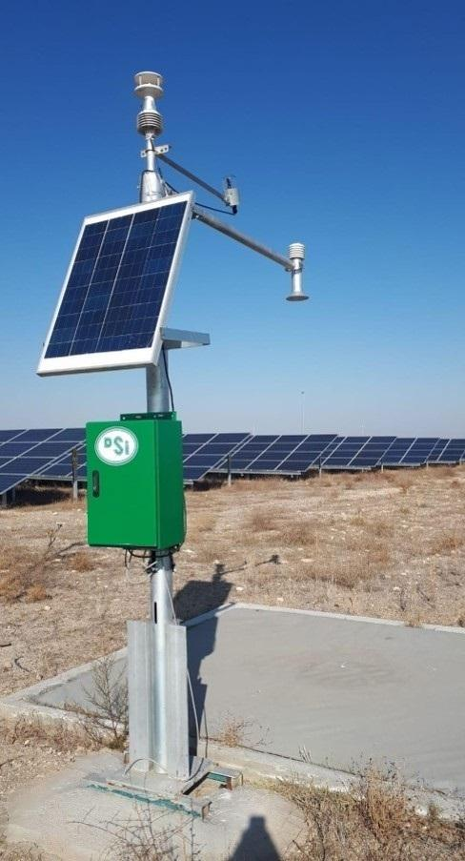
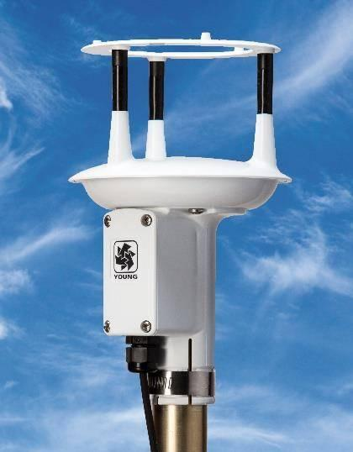
Description
Measures wind speed and direction using ultrasonic sound waves transmitted between sensors.
Features
- No moving parts
- Very fast response
- High accuracy
- Low maintenance
Applications
- Weather stations
- Wind energy
- Environmental monitoring
- Scientific research

5. Pitot Tube Anemometer
# Source: AI Source: Provided by: [Data Path: Persons Table -> ID Column: 1, Name_En Column: Motasem Essam] -> From: [ChatGPT] on [7/17/2026
Description
Determines airspeed by measuring the difference between total pressure and static pressure.
Features
- Suitable for high-speed airflow
- Often connected to a digital pressure meter
- Widely used in duct measurements
Applications
- Aircraft
- HVAC ducts
- Industrial ventilation
- Airflow testing

6. Thermal Anemometer
# Source: AI Source: Provided by: [Data Path: Persons Table -> ID Column: 1, Name_En Column: Motasem Essam] -> From: [ChatGPT] on [7/17/2026
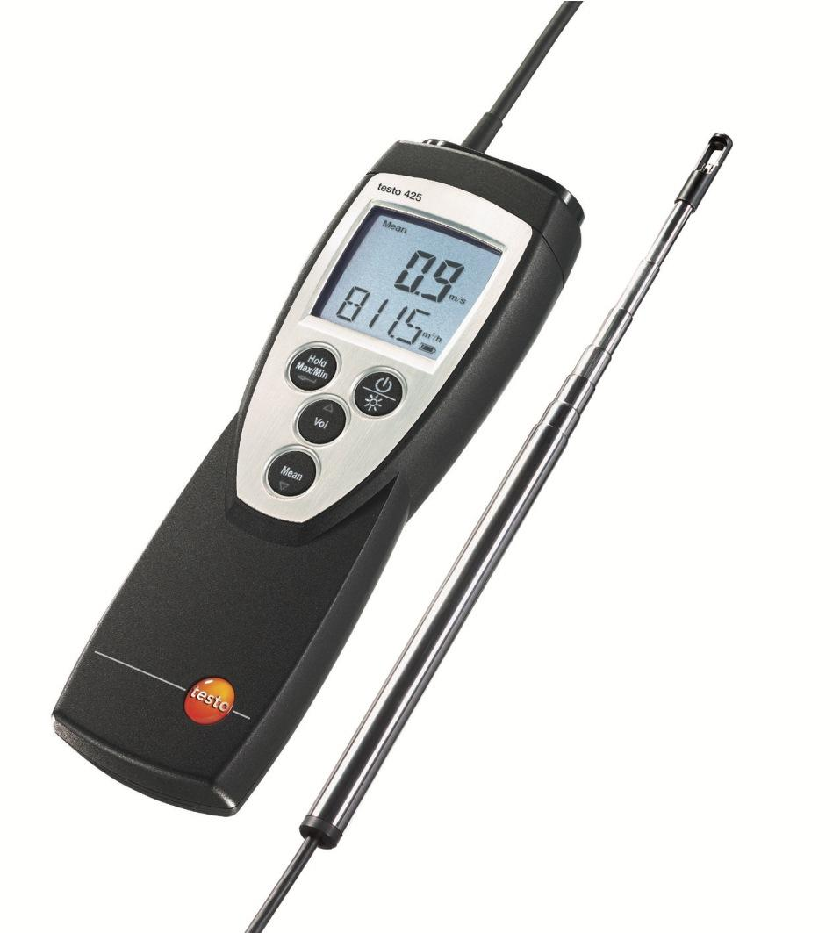

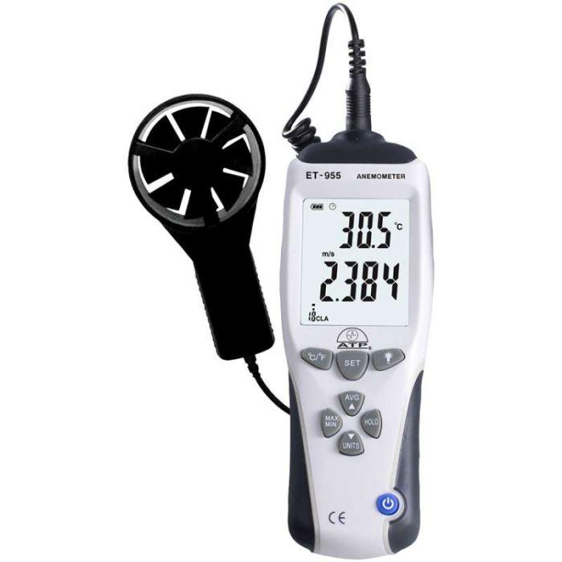
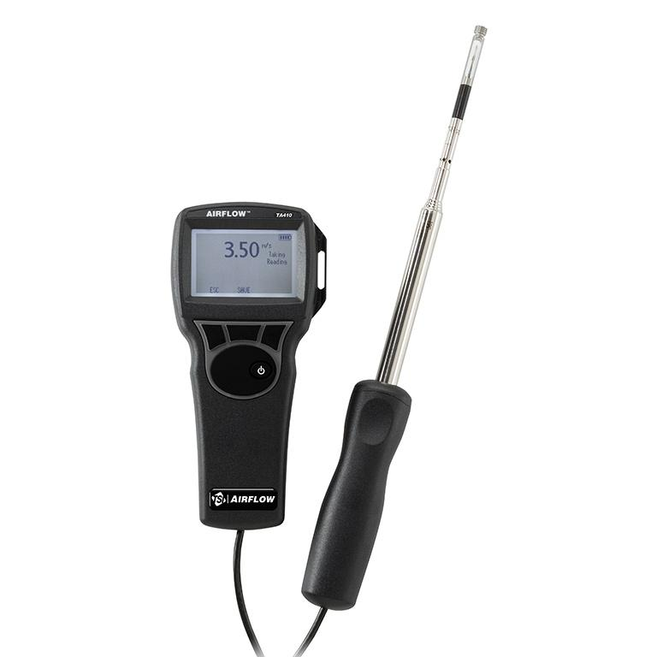
Description
Measures airflow using a heated sensor, similar to the hot-wire principle, but with more rugged sensor designs for industrial applications.
Features
- High sensitivity
- Suitable for clean air measurements
- Digital display
Applications
- Clean rooms
- HVAC systems
- Laboratory airflow measurements
- Industrial ventilation

7. Laser Doppler Anemometer (LDA)
# Source: AI Source: Provided by: [Data Path: Persons Table -> ID Column: 1, Name_En Column: Motasem Essam] -> From: [ChatGPT] on [7/17/2026
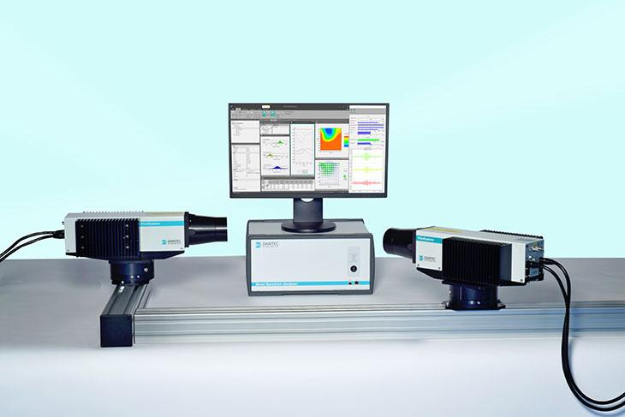
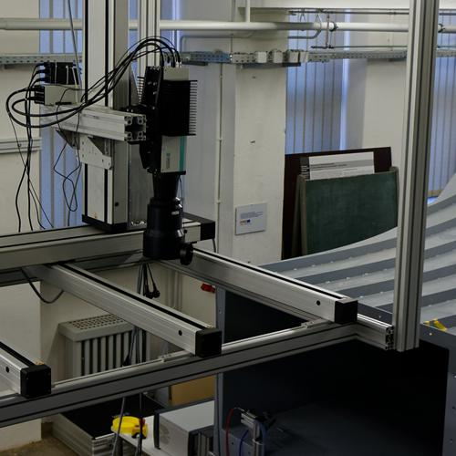
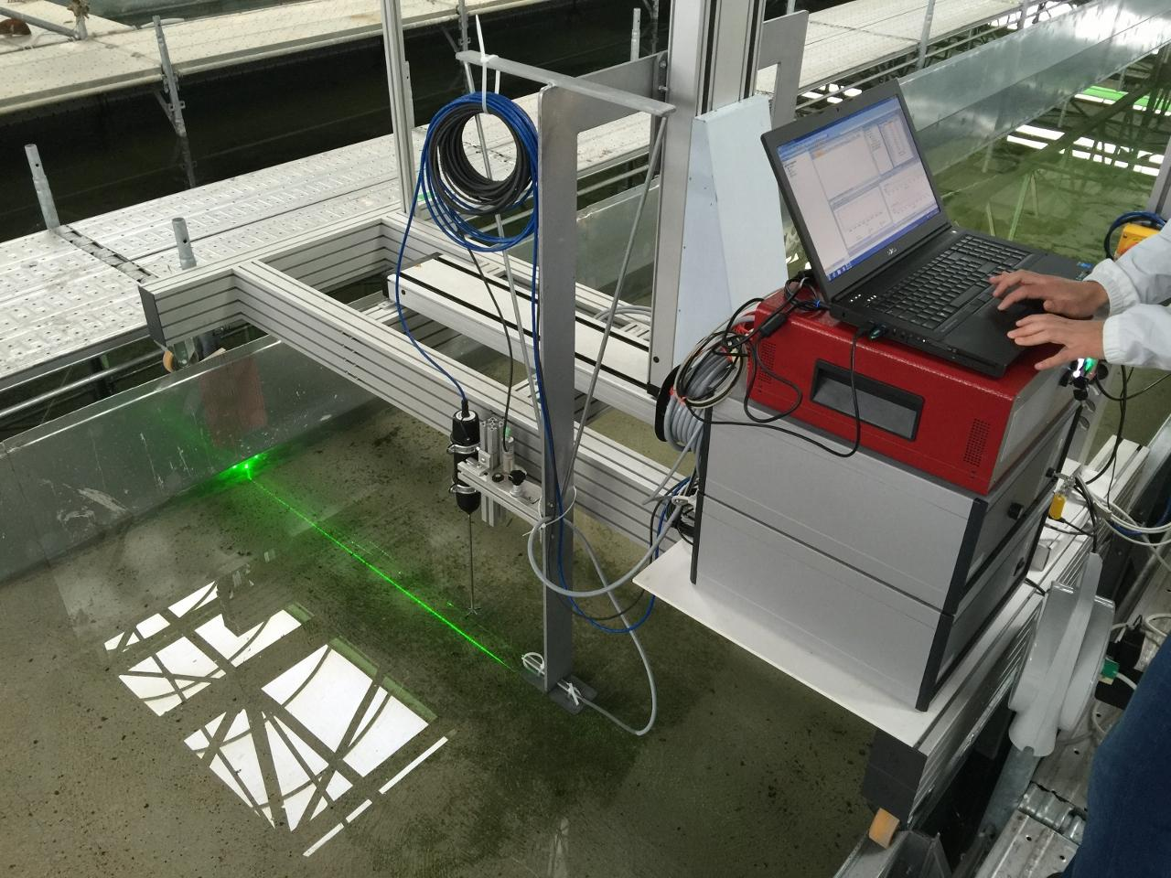
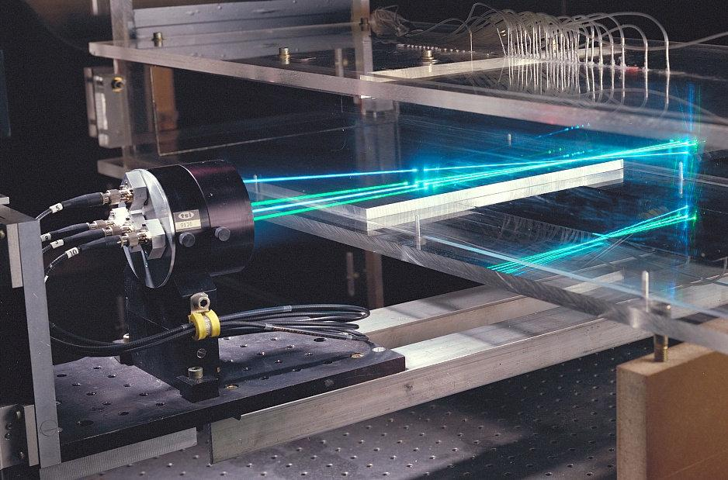
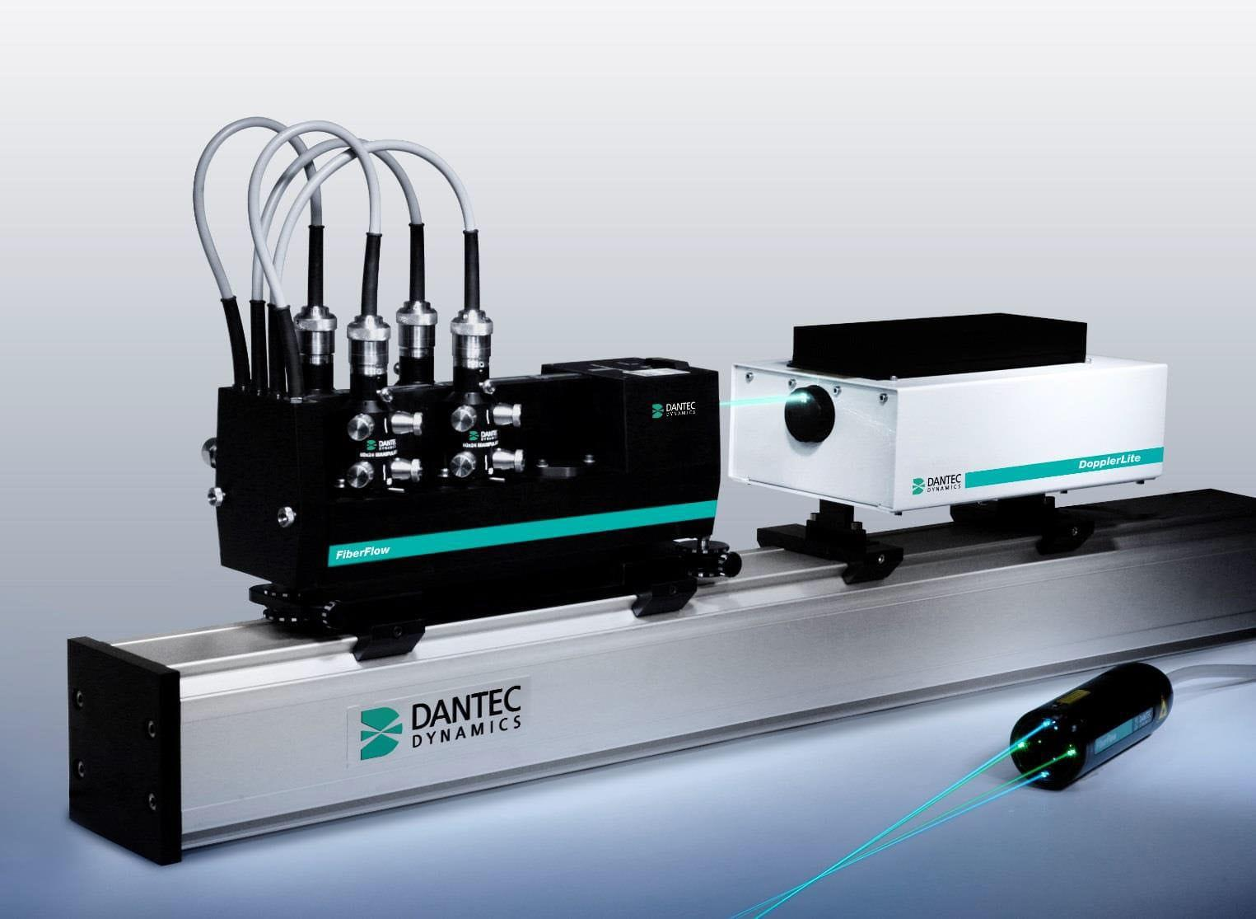
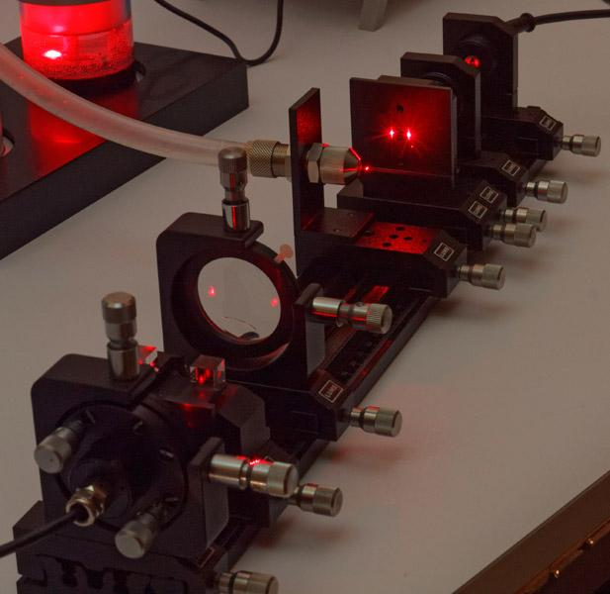
Description
Uses laser beams and the Doppler effect to measure the velocity of moving particles within an airflow without disturbing the flow.
Features
- Extremely high precision
- Non-contact measurement
- Advanced laboratory instrument
Applications
- Fluid dynamics research
- Wind tunnel experiments
- Aerospace engineering
- Scientific laboratories

Measuring Units
# Source: AI Source: Provided by: [Data Path: Persons Table -> ID Column: 1, Name_En Column: Motasem Essam] -> From: [ChatGPT] on [7/17/2026]
Anemometers commonly display:
- Meters per second (m/s)
- Kilometers per hour (km/h)
- Miles per hour (mph)
- Knots (kn)
- Feet per minute (ft/min)

Measuring Range
# Source: AI Source: Provided by: [Data Path: Persons Table -> ID Column: 1, Name_En Column: Motasem Essam] -> From: [ChatGPT] on [7/17/2026]
The measuring range depends on the instrument type.
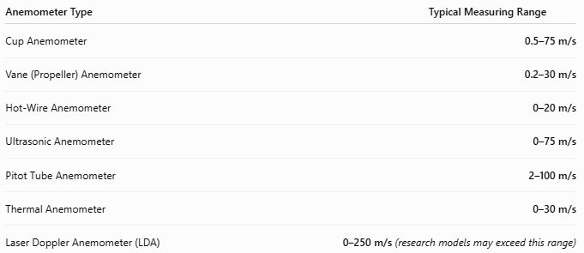
Anemometer Type | Typical Measuring Range
Cup Anemometer | 0.5–75 m/s
Vane (Propeller) Anemometer | 0.2–30 m/s
Hot-Wire Anemometer | 0–20 m/s
Ultrasonic Anemometer | 0–75 m/s
Pitot Tube Anemometer | 2–100 m/s
Thermal Anemometer | 0–30 m/s
Laser Doppler Anemometer (LDA) | 0–250 m/s (research models may exceed this range)

Resolution
# Source: AI Source: Provided by: [Data Path: Persons Table -> ID Column: 1, Name_En Column: Motasem Essam] -> From: [ChatGPT] on [7/17/2026
Resolution is the smallest change in wind speed that can be displayed.
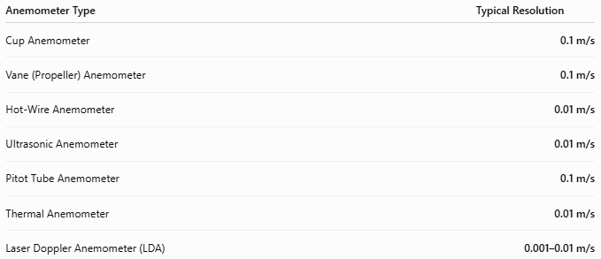
Anemometer Type | Typical Resolution
Cup Anemometer | 0.1 m/s
Vane (Propeller) Anemometer | 0.1 m/s
Hot-Wire Anemometer | 0.01 m/s
Ultrasonic Anemometer | 0.01 m/s
Pitot Tube Anemometer | 0.1 m/s
Thermal Anemometer | 0.01 m/s
Laser Doppler Anemometer (LDA) | 0.001–0.01 m/s

Accuracy
# Source: AI Source: Provided by: [Data Path: Persons Table -> ID Column: 1, Name_En Column: Motasem Essam] -> From: [ChatGPT] on [7/17/2026
Accuracy indicates how closely the measured wind speed matches the actual wind speed.
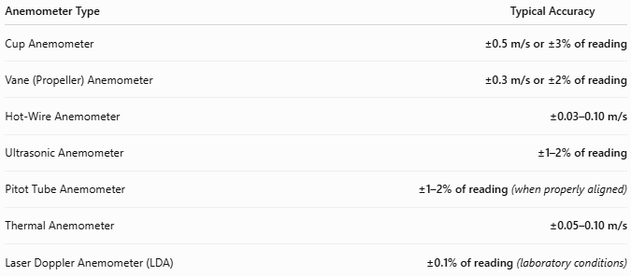
Anemometer Type | Typical Accuracy
Cup Anemometer | ±0.5 m/s or ±3% of reading
Vane (Propeller) Anemometer | ±0.3 m/s or ±2% of reading
Hot-Wire Anemometer | ±0.03–0.10 m/s
Ultrasonic Anemometer | ±1–2% of reading
Pitot Tube Anemometer | ±1–2% of reading (when properly aligned)
Thermal Anemometer | ±0.05–0.10 m/s
Laser Doppler Anemometer (LDA) | ±0.1% of reading (laboratory conditions)

Notes
- Hot-wire anemometers provide the highest sensitivity for measuring very low air velocities.
- Ultrasonic anemometers offer excellent long-term accuracy because they have no moving parts.
- Cup anemometers are the standard choice for weather stations due to their durability.
- Pitot tube anemometers require proper alignment with the airflow for accurate measurements.

How to Use an Anemometer
# Source: AI Source: Provided by: [Data Path: Persons Table -> ID Column: 1, Name_En Column: Motasem Essam] -> From: [ChatGPT] on [7/17/2026
- Turn the instrument on.
- Select the desired measurement unit.
- Position the sensor in the airflow.
- Hold the instrument steady or mount it securely.
- Wait for the reading to stabilize.
- Read the displayed wind speed.

Example
# Source: AI Source: Provided by: [Data Path: Persons Table -> ID Column: 1, Name_En Column: Motasem Essam] -> From: [ChatGPT] on [7/17/2026
Display reading:
8.5 m/s
Measured wind speed:
8.5 meters per second

Applications
# Source: AI Source: Provided by: [Data Path: Persons Table -> ID Column: 1, Name_En Column: Motasem Essam] -> From: [ChatGPT] on [7/17/2026
Anemometers are used in:
- Meteorology
- Weather stations
- Aviation
- Wind farms
- HVAC systems
- Environmental monitoring
- Wind tunnel testing
- Marine navigation
- Scientific research

Advantages
# Source: AI Source: Provided by: [Data Path: Persons Table -> ID Column: 1, Name_En Column: Motasem Essam] -> From: [ChatGPT] on [7/17/2026
An anemometer:
- Measures wind speed accurately.
- Provides real-time airflow data.
- Supports weather forecasting.
- Improves HVAC performance evaluation.
- Assists wind-energy assessments.

Limitations
# Source: AI Source: Provided by: [Data Path: Persons Table -> ID Column: 1, Name_En Column: Motasem Essam] -> From: [ChatGPT] on [7/17/2026
An anemometer:
- Requires correct positioning in the airflow.
- Mechanical types can wear over time.
- Dirt or ice may affect outdoor sensors.
- Hot-wire sensors are delicate and easily damaged.

Sources of Error
# Source: AI Source: Provided by: [Data Path: Persons Table -> ID Column: 1, Name_En Column: Motasem Essam] -> From: [ChatGPT] on [7/17/2026
Instrument Errors
- Calibration drift
- Worn bearings (cup and vane types)
- Sensor contamination

User Errors
- Incorrect orientation
- Holding the instrument in turbulent airflow
- Blocking airflow with the hand or body

Environmental Errors
- Turbulence
- Rain
- Ice
- Dust accumulation
- Nearby obstacles affecting wind flow

Comparison with Other Speed Measuring Instruments
# Source: AI Source: Provided by: [Data Path: Persons Table -> ID Column: 1, Name_En Column: Motasem Essam] -> From: [ChatGPT] on [7/17/2026
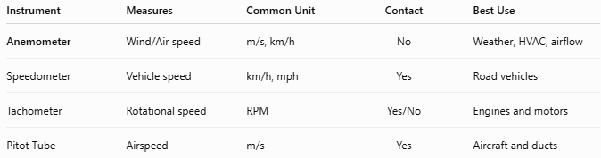
Instrument | Measures | Common Unit | Contact | Best Use
Anemometer | Wind/Air speed | m/s, km/h | No | Weather, HVAC, airflow
Speedometer | Vehicle speed | km/h, mph | Yes | Road vehicles
Tachometer | Rotational speed | RPM | Yes/No | Engines and motors
Pitot Tube | Airspeed | m/s | Yes | Aircraft and ducts

Care and Maintenance
# Source: AI Source: Provided by: [Data Path: Persons Table -> ID Column: 1, Name_En Column: Motasem Essam] -> From: [ChatGPT] on [7/17/2026
To maintain accuracy:
- Keep sensors clean.
- Protect moving parts from dust and moisture.
- Calibrate periodically.
- Store in a protective case.
- Replace damaged bearings or propellers if required.

Common Mistakes
# Source: AI Source: Provided by: [Data Path: Persons Table -> ID Column: 1, Name_En Column: Motasem Essam] -> From: [ChatGPT] on [7/17/2026
- Measuring in turbulent airflow.
- Incorrect sensor orientation.
- Ignoring calibration.
- Blocking airflow during measurement.
- Using the wrong measurement unit.

Key Points
# Source: AI Source: Provided by: [Data Path: Persons Table -> ID Column: 1, Name_En Column: Motasem Essam] -> From: [ChatGPT] on [7/17/2026
- An Anemometer measures wind or air speed.
- Common types:
  - Cup Anemometer
  - Vane (Propeller) Anemometer
  - Hot-Wire Anemometer
  - Ultrasonic Anemometer
  - Pitot Tube Anemometer
- Common units:
  - m/s
  - km/h
  - mph
  - knots
- Widely used in meteorology, HVAC, aviation, environmental monitoring, and wind-energy applications.

Conclusion
# Source: AI Source: Provided by: [Data Path: Persons Table -> ID Column: 1, Name_En Column: Motasem Essam] -> From: [ChatGPT] on [7/17/2026
An Anemometer is a specialized speed-measuring instrument designed to measure the velocity of moving air or wind. By employing different sensing technologies—such as rotating cups, propellers, heated wires, ultrasonic waves, or pressure differences—it provides accurate airflow measurements across a wide range of applications. Its importance in weather forecasting, aviation, HVAC performance, environmental monitoring, scientific research, and renewable energy makes it one of the most essential instruments for measuring air movement.

